Appendices

Appendix 1 – Strategic

Appendix 1.1 Design Checklist

Introduction

Purpose of this design code/guide - what it does
The design guide sets out the key considerations that applicants will need to respond to in order to demonstrate high-quality design in line with requirements of Policy HD7.
The guide also brings together broader design considerations in Oxford which will arise from the requirements of policies across the Local Plan.

Structure of this design code/guide
The design guide is structured as a series of questions which the City Council will look to see answered as part of a planning application. These answers will explain the design approach, most likely in the design and access statement. Under each question are a series of prompts intended to help flag key issues, the relevant Local Plan policies are noted, as are helpful guidance documents or information sources. Many of the topics are inter-related, cross references are provided where this is clear although the issues covered should also be considered as a whole. Context should always be the starting point of the design process, and the contextual analysis will inform many aspects of design. For major developments, where early consultation with the community is encouraged in the Statement of Community Involvement, this should include engagement on context and how that may inform design.
The structure of the document has been loosely guided by the key principles of high-quality design as set out in the National Design Guide, tailored to an Oxford setting.

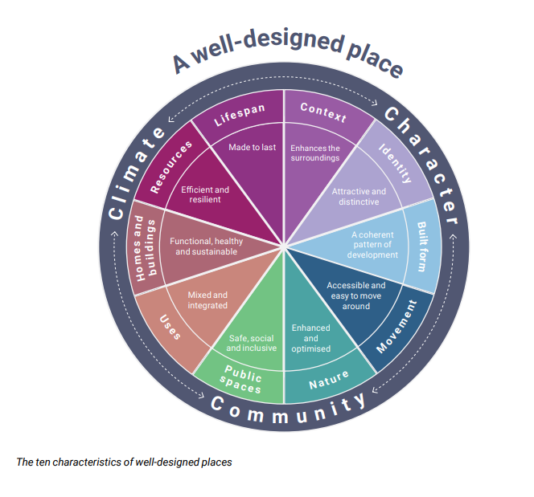

Context
The context refers to the attributes of the site and its surroundings. It applies to the physical, but also cultural and historic context. A thorough understanding of context is a key starting point in good design, not only will it help to ensure a high-quality development that fits in with the surrounding area but it will also help to identify the key opportunities and constraints that the design process will need to work at an early stage to ensure a successful application.

C.1 What are the key features identified in the contextual analysis that should inform the design?
The constraints and opportunities plan should form a key part of the design and access statement, explaining the design story and showing how the key features of the site have been identified and help to inform the design proposal. The analysis should therefore be wide-ranging, including but not limited to:
- What is the landscape/townscape character of the area (e.g. Riparian edge, clay hills, gravel raised bed) and the urban character of the area? What is the built-form in the area? Are there features that have a positive or negative impact on character, and how should this affect the design? Relevant may be roofscapes, materials, detailed features such as windows, boundary treatments and height and massing. Heritage assets on or near the site will need particular attention. See: Oxford in its Landscape Setting https://www.oxford.gov.uk/downloads/download/1054/014_des_-_design_and_heritage
- What are the major movement corridors around the site – including roads, public transport routes, cycleways and footpaths. What is movement like along these corridors at present? Are there barriers or pinch points which constrict movement? What is access like into the site?
- What is the natural landscape like around and on the site? Is there green open space and what function does it provide? What is tree canopy cover like? Are there green or blue corridors or is there the potential to establish these by connecting up fragmented areas? What habitats are present and are there designated ecological or geological sites that could be susceptible to harm? Are there waterways or other blue features? See: Oxford Urban Forest strategy; Green Infrastructure study 2022; Playing pitches study; Natural England mapping
- What is the heritage context of the area? This is expanded upon in section C2 below.
- What other constraints could be present (e.g. areas of flood risk, air pollution hotspots, noise environments)?
- What features/constraints could be present below the ground (e.g. utilities, soil quality/typologies; groundwater levels and movement; archaeology; contaminated land)?
Additional data sources (such as up-to-date satellite imagery; biodiversity/contamination/hydrology surveys) could be used to inform the site-specific context.

C.2 What is the heritage and cultural context of the site and are there any heritage assets that may be affected by the development?
The historic character of the city is unique and comprises a range of heritage assets, many of which are designated either locally or nationally.
- When considering whether there are any heritage assets that may be affected by the development, the setting of these must also be considered. If there is to be any impact on a heritage asset, a heritage statement will be required. This may be standalone or form part of the design and access statement. Policies HD1-HD6 set out what is expected.
The following sources of information will help to identify whether any heritage assets or their setting may be affected by the development:
- Historic England List https://historicengland.org.uk/listing/the-list/map-search?clearresults=True/
- Conservation Area Maps and Appraisals https://www.oxford.gov.uk/info/20195/conservation_areas/871/conservation_areas
- Oxford Heritage at Risk https://www.oxford.gov.uk/info/20196/oxford_heritage_asset_register/874/oxford_heritage_asset_register_-_overview
Heritage assets offer an opportunity to maintain and inject local character. They are distinctive, and responding to them positively will help ensure a contextually rich design, as well as maintaining the significance of the asset.

C.3 How has the design rationale responded to the presence of important views across the city?
Views are particularly important in Oxford: there are wide-ranging views to and from and across the buildings in the historic core which include the internationally renowned skyline, which as an entity is considered a heritage asset; and views out towards the city’s unique setting (which includes the green hills rising up around the city and the low-rise character of its suburbs). Also relevant are the views and setting of each individual tower and spire that comprises the iconic skyline, as this includes individually listed buildings of the highest significance.
Several types of views need to be considered:
- Long ranging views across the city that are protected (policy HD9) - information on these can be found at: https://www.oxford.gov.uk/info/20064/conservation/876/oxford_views_study
- Views identified in conservation area appraisals – typically shorter in range but important role in supporting the character of these areas – information on these can be found at: https://www.oxford.gov.uk/info/20195/conservation_areas
- Views out towards the city’s landscape setting and low-lying suburbs and landform which visually present the story of Oxford’s history and development
- Locally important views that create or aid appreciation of the townscape and character of the area.
The high buildings TAN identifies four principal visual characteristics that are worth considering when assessing views and how a building could impact on them:
- The iconic spires and silhouette of the historic city centre.
- The open and natural character of the river floodplains.
- The green (wooded or agricultural) backdrop to the city formed by the surrounding hills.
- The enclosed and often intimate views within the city centre.

Built form
Built form refers to the 3-D arrangement of streets, open spaces, development blocks and buildings. An appropriate built form and the design rationale will need to explain how the contextual analysis has informed this. It is important that the elements of built form set out below are not considered in isolation, later sections in the guide such as movement and public space also play an important role in determining the correct arrangement for the site.

Site layout and block arrangement

B.1 Has the proposed site layout been informed by the features identified through the contextual analysis?
The layout of development on a site and the siting of uses within that need to consider the contextual analysis. A comprehensive analysis should help to inform which parts of the site are more sensitive to development or need to be avoided completely. Policy HD8 sets out important considerations regarding the site’s context that will affect the overall density of the development.
- Does the contextual analysis suggest that any areas of the site need to be left undeveloped, for example because of archaeological remains, valuable habitats, mature trees or areas of flood risk? These undeveloped areas will not only affect site layout and block arrangement but also height/massing and density, and will influence the pattern of streets.
  - Certain constraints may be able to be overcome through targeted design measures to allow development to come forward in an acceptable way – e.g. contaminated land could be remediated; noise concerns could be overcome with sufficient attenuation measures, open space may be able to be re-provided.
  - Other constraints may necessitate an arrangement of the site that completely avoids the concern – for example if part of the site is particularly high risk from flooding or to ensure a sufficient buffer to a sensitive ecological site nearby or a watercourse.
- The built form of the surrounding area will likely influence site layout. The design will need to respond to the way that buildings and spaces are arranged around the development site, including their heights, massing and density. Existing building lines should also be considered, and in most cases it will be appropriate to continue these where relevant. If that is not the design choice, the rationale should be explained.
- Movement will also be a key part of informing the site layout. The contextural analysis should identify existing accesses, roads and footpaths, and key destinations in the surrounding area. The Movement section has more detailed considerations but particular questions that may influence layout could include:
  - Are existing accesses adequate, or do they need to be moved or enhanced?
  - Can access be achieved (or are any additional accesses needed) for vehicles or just for cyclists and pedestrians to improve their choice of routes and to allow direct crossing of desire lines?
  - How direct is access through the site to surrounding destinations such as shops and bus stops and can it be made more direct?
  - How easy is it to navigate through the public realm? Key navigating points, or nodes, may be marked by buildings with notable features to make clear that it is a significant point in the network and to make routes memorable. Small block sizes can help maximise choice of routes.

B.2 What is the strategy behind the configuration of development blocks and how has this been tailored to the opportunities and constraints of the site?
Proposals should consider how different configurations of block typologies can satisfy the need of the development and respond to existing context. In general, key considerations will be the orientation of blocks, how they fit into the surroundings and maintain or create views and glimpses, the impact on solar gain, any wind tunnel effects and so on. The location of uses within blocks may need to be tailored to specific constraints on the site and surrounding area, for example noise pollution. Retail and similar uses that create activity will be best located on a frontage on primary streets. The uses proposed will influence the type of blocks. There are specific considerations for particular block arrangements:
- Standalone detached blocks may be more suitable for constrained sites or infill development, however standalone buildings can also be used in key locations on larger sites as statement buildings that can bring interest and improve legibility of site. Careful consideration needs to be given to the spaces between buildings to ensure they are integrated into their surroundings successfully. They typically give fewer opportunities to establish defined open space so the surrounding public realm will be particularly important establishing their character and setting.
- Courtyard or perimeter block arrangements establish more continuous building lines along the boundaries of an urban block and can offer more opportunities to contain shared space within. The shape and size of shared spaces within the blocks can be varied based upon the needs of the occupants but should also be based upon wider environmental considerations such as presence of daylight/overshadowing.
- Where a site requires more flexibility but an appropriate amount of space more hybridised blocks arrangements can be more effective. This incorporates more breaks in building lines that can act as secondary access routes. Hybrid arrangements can allow for more variation in heights and massing, introducing more visual interest as well as opportunities to attain greater levels of floorspace whilst also keeping the footprint of the building minimised. Because of the more open nature of this type of arrangement, they can include semi-private amenity spaces that have a stronger relationship with the surrounding public realm.
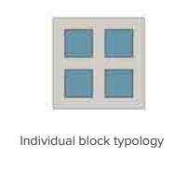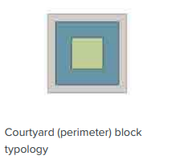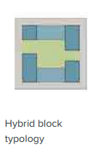

B.3 How have the heights and massing of buildings been determined and how is this justified?
Oxford is particularly renowned for its spires and iconic skyline. Heights and massing of buildings should be informed by the context of the site (neighbouring uses and local built form and character) as well as the needs of the uses proposed.
- The height at which a building is considered to be high will be dependent on its surrounding context and will vary across the city. Even an increase in height of a single storey may constitute a high building. Building heights may impact views and Policy HD9 relates to high buildings. An understanding of context is critical. High buildings may offer visual interest and higher density. The choice of height should be design led, and the overall design will affect the impact of the height. Buildings at greater mass will often be more impactful at a lower height than a building of less mass. The impact on the heritage asset of the historic core is particularly important to consider.

- The high buildings TAN sets out four visual tests which should be investigated as part of the design iteration process and included in the final submission proposal to demonstrate the potential effects a high building may have to the character, visual and heritage resource. These tests are
- Visual obstruction – the physical obstruction of a feature or component in the view caused by a high building.
- Visual Competition / Complement – the siting of a high building within the same view as the feature such that the two are viewed together.
- Skylining – when high buildings break the skyline, horizon or silhouette, which may be formed by built form or vegetation.
- Change of character – occurs when the composition of a view is altered to the extent the character of the view is discernibly different to that of the existing.
- There are other key design considerations when designing tall buildings. The profile or silhouette of the building is important. The articulation of built form should clearly respond and contribute positively to Oxford’s skyline. The scope for diversity of profile / silhouette will depend on demonstrating a clear understanding of the context and positive contribution to the modulation of the city’s skyline. High building designs should provide well organised and designed roof environments and contribute to the modulation of the city’s skyline.
- Microclimate is another important consideration as greater heights have greater potential to modify the microclimate. Effects may include the tunnelling of wind, partial or permanent shading of adjacent areas and / or intensification of solar irradiation. Privacy and access to light will also need to be considered and the massing will need to be designed in a way that supports this.
- Think about how the visual impact of the development will be influenced by the bulk and massing of buildings including the relationship between different sections of the building (e.g. how its base, its middle and its top are balanced out). Larger, unbroken facades that form bulky or homogenous building lines can have a more significant impact on the streetscape and views from a distance, which may be more harmful in more sensitive areas of the city. Taller buildings of slender form are more likely to be more appropriate than bulky tall buildings.
- Whilst more complicated massing which results in a higher surface area (sometimes referred to as a high form factor) can come at a detriment to energy efficiency (see Resources section), consider how massing and building facades can be strategically designed to create visual interest through use of smaller components or features that can create depth and rhythm where appropriate (see Articulation of building features under the Identity and Character section).
- Consider the experience of people within the streetscape as they pass by and use the building. Think about how the building fronts onto the street and how design relates to the human scale so that spaces created between buildings are welcoming and pleasant to inhabit.

B.4 How do alterations to existing buildings respect the form, scale, character and appearance of the existing building and surrounding area?
The same design principles apply when considering alterations to existing buildings; any alterations should respect the form, scale, character and appearance of the existing building. When extending a building, the impact on the existing building and surrounding buildings needs careful consideration.
The privacy and internal daylight and sunlight of the existing property and surrounding properties maybe negatively affected. Policy HD11 sets out expectations for levels of privacy, sunlight and daylight, including the 25º and 45º guidelines. With an extension there is more limited scope to consider orientation, meaning the height and length of the extension and any impacts on overshadowing will be particularly important, as well as the size and placement of windows and rooflights.

Movement
The quality of the movement network into and through a development plays an integral role in establishing its character and how it functions. Particular focus should be on enabling safe and easy walking and cycling as well as on the needs of those who are less mobile. A quality movement strategy will play a role in supporting people to access daily needs such as shops and facilities; employment and services; accessing open space and nature without having to rely on private vehicles. The way that streets are laid out can support social interaction and promote a safer public realm. Movement considerations will also need to address access to public transport for journeys beyond the local area and balance out the need for parking for those who do rely upon private vehicles.

M1 Has movement into and through the development been considered and what is the strategy for this?
It is important that sites integrate well with the surrounding area. As part of the contextual analysis (as discussed in the Context section) movement corridors of various transport modes in and around the site should have been identified including barriers and opportunities to movement which new development could respond to.
- New developments should provide permeable streets to tie in with existing street networks and secure improved connectivity.
- Levels of movement will vary, with higher levels of activity likely to be located around particular uses like shops, schools and areas of employment and lower levels of activity in other areas such as residential streets.
- Very large sites may have streets across a hierarchy e.g. primary, secondary and tertiary routes. Even for small sites with a single access route, consideration of the position of this route within the surrounding street hierarchy should inform design.
- The street width, building height, enclosure, set backs and uses are likely to differ between the different street types to help distinguish between them (and therefore aid wayfinding) and to accommodate the level of activity of movement on them.
- Streets should not be vehicle dominated but should reflect a more human scale and allow for and encourage more active and sustainable modes of transport. Opportunities will be available for accommodating other design features, such as greening in the form of trees or SuDS, as well as street furniture and services but a balance needs to be struck to ensure that these spaces do not become cluttered.
- Narrower streets (secondary and tertiary routes) offer opportunities to slow down or remove through traffic and prioritise active travel like walking and cycling and are likely to be more fitting of residential areas. The design of new streets and alterations to existing ones should seek to encourage social interaction, natural surveillance and opportunities for active and sustainable traffic by prioritising the quality of the public realm and removing the dominance of the car in the street user hierarchy.

M2 Has active travel been prioritised and how has design been used to ensure safety and security for all modes and different groups?
On routes of all sizes, pedestrian and cyclist friendliness should be maximised to ensure that all users are safe and comfortable throughout Oxford’s movement network. On secondary and tertiary streets, the street user hierarchy should prioritise children, pedestrians, cyclists over motor vehicles and the built form and street design should reflect this. Oxfordshire County Council’s Street Design Guide provides useful advice.
- Oxford’s communities are diverse with varying needs and vulnerabilities that can modify their experience of the public realm at different times; this needs to be taken into consideration in designing movement routes. Is there sufficient pavement space for different users needs – e.g. those with pushchairs, individuals in wheelchairs or with other assisted mobility needs?
- Consider how route design will impact perceptions of security and promote safety for different groups, such as by facilitating desire-lines for pedestrians and cyclists wherever possible including across open spaces. Avoid creation of spaces and routes that feel cut off or lacking in visibility and take opportunities to reduce street crime/fear of crime and deter anti-social behaviour. Think about how different routes might be experienced at different times of the day and in different seasons, how could perceptions of safety change at night or in bad weather and how can street design be used to improve these (e.g. lighting, shade and shelter).
- Consider also how use of planting could be incorporated into roads, streets and paths to soften the urban fabric and encourage active travel across the site and beyond. Green features like trees that provide canopy cover can be beneficial for providing shade to pedestrians during the summer months as well as movement corridors for wildlife; careful placement of hedges can act as a buffer to air pollutants as well as softening noise impacts. However, care should be taken in choice of species and placement to ensure negative impacts are avoided – for example certain species can produce pollutants that reduce air quality, whilst poor design can also trap air pollution (e.g. large tree canopies reducing air flow within narrower street canyons). See Nature section for more information.
- Think about how street design can support active travel in other ways, for example by providing secure storage for bicycles to ensure that people have somewhere safe to leave bikes in between travelling. Think about how and where these should be located, think about where the demand for storage would be. Is it convenient to use? Does it benefit from natural surveillance? Has situation avoided creating hazards for other road users?

M.3 How does the layout and design of streets promote access to public transport and create areas with minimal traffic
Lower traffic streets allow more space for social interaction and for children to play and have been demonstrated to increase ‘neighbourliness’ and access to active and more sustainable travel and freedom of movement for children. Even in a relatively small scheme, attention can be given to creating areas with low or no vehicular traffic.
- Placement of parking areas is important, particularly on schemes with only one vehicular access. Is it possible to position parking so that cars do not need to circulate around the whole development? Has permeability been maximised for pedestrians and cyclists?
- Most schemes in Oxford will be smaller, infill schemes on or near to existing bus routes, but will not have new bus routes within them. However, in cases where bus routes are needed within a scheme, these must be direct, wide and straight enough to be easily navigated for a bus driver with adequate space for passenger to wait comfortably, without conflicting with other road users.
- Think about requirements of other services like delivery vehicles and waste collection and design routes to ensure they can move efficiently. All streets should have some provision for emergency access, regardless of hierarchy. Solutions for otherwise pedestrian areas, such as designated delivery zones, may be useful.

High quality public spaces

Except for the smallest developments, most new developments will include public spaces. Multi-functionality is encouraged, from allowing movement and access to allowing social activities and recreation. The link with the Green Infrastructure strategy will influence whether there are long, narrow strips of green corridor, larger and more formal spaces, natural spaces or small pocket parks.

P.1 Are all spaces clearly defined, with a clear purpose, with no awkward or leftover spaces?
Public spaces should be well-defined and clearly distinguished from private spaces. The purpose of the public spaces should be clear, with a certain amount of flexibility about their future use. For example, if routes are segregated, with pavements or cycle lanes for pedestrians and cyclists, the divisions should be clear, but potential for change in the future should also be considered, for example to a shared space. Public open spaces should be obviously public, clearly visible, and accessible. Awkward patches of land that are too small to have an obvious function should be avoided. Landscaping and street furniture such as benches and carefully locating small spaces within the network to create a small social or stopping place will help to ensure they are functional and not wasted.

P2 How are public spaces designed to give a sense of safety
When a public space is overlooked, with doors and windows fronting onto it, it can offer the user passing through a sense of security, this is particularly important at night and for more vulnerable pedestrians. Is there overlooking to create a sense of surveillance? Are all external public spaces such as streets and parks overlooked by windows serving habitable rooms in buildings and adjacent activity?

P3 How do public spaces support social interaction and is there adequate space in the public realm to linger and walk side-by-side?
The public realm should do more than just enable people to walk from a to b. Except in the smallest infill sites with only a short access road, there should be an opportunity to design the public realm to include wider and more spacious areas that enable people to interact with others. Routes for pedestrians should not be so narrow as to require single-file walking. Oxfordshire County Council’s Street Design Guide provides useful advice.

P4 How are any public open spaces designed with all ages and needs in mind?
Public spaces should be useable and attractive for everyone. Playable space and playful streets that are welcoming to all support sustainable communities and wellbeing. This is important in all of the public realm, not just large parks and squares and playgrounds. Smaller, informal spaces including pavements, pocket parks and small community gardens and growing spaces can all provide these opportunities. Those with visual or hearing impairments benefit from well-designed spaces that are easy to navigate and pleasant to use.

P5 How has the public realm been designed to be flexible, adaptive and stimulating
Public realm should be able to respond and adapt to various uses and needs and it should also be engaging. Variety in the public realm will help achieve this. How will there be opportunities for children and adults to play games and be active or stop and watch the world go by? All senses should be considered, including the sounds that different planting and surfacing may make, visual variety and smells.

Something about clutter in the public space – advertising, street furniture etc?

Identity and character
Identity and character are influenced both at a broad level as was discussed under the Built Form section, but also on a more detailed level, by the articulation of specific features of buildings and spaces as well as the choice of materials. Where these elements come together successfully, they can help to generate local character that makes a development distinctive and memorable and gives users a sense of pride as well as establishing places that are sustainable and resilient for the future.

Articulation of building features

I.1 Do the proposals contribute positively to the roofscape?
Oxford has a rich roofscape and new development needs to consider any impact on it. The positive design of roofscape will help to enhance any significant long views the development might be part of and also the experience of the place at street level. The contextual analysis undertaken on the development site will help inform an appropriate approach to the design of rooftops.
- How the design of roofscape sits within longer views will be particularly important where the development is sited within the protected views that cross the city, but also where it is sited within views identified within Conservation Areas Appraisals – See Views section.
- Along with the presence of protected views, consideration should be given as to whether there are specific characteristic aspects of roofscape in the area – this will be of particular relevance where the site is located within a conservation area – for many of the CAs the style of rooftop is an important element in their designation.
- Variety in the roofscape through a mixture of flat and articulated roofs can help to provide visual interest. Think strategically about the appropriateness of additional features such as dormers or extractors. Where incorporated carefully, these can add visual interest and punctuate the roofline, but their incorporation needs to consider the wider context of the area as well as the overall balance of other features on the building.
- Where roofscape design is less constrained and particularly on larger developments or those within constrained site boundaries, consider how design could support the use of rooftops as communal areas or private amenity space. Equally, think about how rooftops can support wider environmental/sustainability objectives such as promoting biodiversity, and rainwater harvesting, as well as roof-mounted photovoltaics (which can be integrated with green or biodiverse/brown roofs). See Nature and Resources sections.

I.2 How have façade details such as windows and entrances been designed with consideration of any positive characteristics in the area?
As with roofscape, the articulation of façade features like windows and doors can play a major role in contributing to the character of the building and the setting of the wider area. Again, think about the contextual analysis and what factors might need to be considered in the design of these features.
- Articulation of the windows on surrounding buildings including their size, positioning and the types of materials used in their construction. Think about how the design of window/doors will fit in with the rhythm of adjacent buildings so that they respect and enhance the positive character of the area where possible. Where contrasting design choices are made, these should be justified.
- As well as the location of windows/doors, think about how the specific glazed features are designed, including how individual panes are subdivided. Large uninterrupted areas of glazing (e.g. a wide, undivided patio door) can give the impression of voids which may be detrimental to overall design depending on where they are located. Conversely, use of glazing that is subdivided on particular facades can draw attention to these elements in a positive way, but can be equally disruptive where multiple styles of sub-division, or uneven subdivision are located on one frontage.
- Think about the impacts of window/door sizing and spacing on internal amenity. Larger areas of glazing can allow for more daylight but could disrupt privacy, so may be more appropriate at levels higher than ground floor. Equally, size and positioning of glazing can impact solar gain and indoor thermal comfort – there are specific requirements for meeting overheating tests set out in the Building Regulations (Part O – Overheating) which need to be balanced out against design aspirations to ensure planning permission is not in conflict with building regulations. See Resources section.

I.3 Attention to detail: storage, waste, servicing and utilities
Design will need to take into account a range of external features servicing the development and its occupants; it is important that their impact is considered both in terms of their location and the materials they are devised from. Are external servicing features such as bin storage facilities, rainwater goods integrated into the design of the development with well considered placement?
- The positioning of features like bins and storage for outdoor equipment (including bikes) at the front of buildings can have a negative impact where they protrude inappropriately as well reducing the perceived activity of frontages which can impact the street scene and reduce perceptions of safety. Think about how these could be positioned away from facades intended to provide active frontages, potentially to the rear of properties and away from the streetscene where possible, though it is important to ensure that there is good access for users and it is acknowledged this isn’t always feasible. Where positioning away from street scene is not possible, there will be a need for high quality materials and more careful design that can reduce impacts.
- Think about the impact of other external features required to provide for essential services such as meter boxes, gutter pipes, satellite dishes and Electric Vehicle charging (see Resources section for more on EVs). Whilst these should again be located in a way that minimises their visual impact and best fits in with the character of the building and the local area, it may not be feasible to fully limit visual impact by position alone. Again, this is where it is important to pay attention to material choice and specific design characteristics like size, colour, and location and factor this early into the design process. Can these features be designed with a similar colour to the wider building? Can features like guttering be integrated into the façade?

I.4 How do the materials chosen reinforce the overall design concept, respect the local context and ensure high quality?
It should be explained in the DAS how the contextual analysis been used to inform the materials chosen. Considerations that may be of relevance as part of the design rationale for materials used could include:
- In many cases it is likely to be appropriate to select materials and vernacular used in the local area as well as wider Oxford. Where contrasting materials are deliberately chosen for example to create visual interest and distinctive style, the design rationale should be justified, including with regard to the impact on existing character.
- It may be appropriate to use combinations of materials or different materials on different parts of the building for example on different storeys or in order to articulate certain parts of the structure. In those cases, the change from one material to another should appear logical and be justified within the design rationale.
- The selection of materials should consider various characteristics including colour, variation, reflectivity, texture of materials.The extent and character of glazing will also influence the appreciation of a building. The use of prominent colours and materials should be carefully considered; muted colours that respect the existing character of Oxford may be most appropriate. Substantially glazed elevations should demonstrate sensitive appreciation of orientation and reflectance.
- Consider the way materials are seen and appreciated under different atmospheric conditions, for example in bright sunshine and at different times of the day and night. This should be tested through the provision of visualisations agreed during pre-application consultation.
- Materials utilised in external/detailed elements like rainwater harvesting (e.g. guttering), boundary treatments (e.g. fences, walls) and other extraneous features, also need careful consideration, particularly where these are publicly visible. Are these of a high quality, durable and in keeping with the wider context of the building and the local area?
- Consideration should also be given to how the materials will perform over time; they should be chosen to be long-lasting and wear and weather well, without degradation of their aesthetic appeal or functionality. This applies to materials used in the buildings and also external areas including private amenity space and public realm which will be subject to differing levels of wear (e.g. weathering). In external areas, materials should be easy to maintain and repair, and when it comes to replacement, easy to source matching materials.
- Other considerations of relevance to material selection could include how they will support other design choices and sustainability. For example, considering the embodied carbon cost of particular materials, as well as thermal performance of fabric materials which is important for energy efficiency and maintaining a comfortable indoor environment throughout year (see Resources section and policies R1, R2 and G9).

Nature - Green Infrastructure and biodiversity
Given the constrained nature of the city and increasing pressures on landscapes and biodiversity arising from all sizes of development, it is essential that the provision of green and blue infrastructure are considered at the earliest stage in the design process. Natural and designed landscapes that integrate existing features and incorporate new features should offer multi-functional benefits including for health and wellbeing, biodiversity, water management and climate change. Impacts on existing biodiversity should be avoided and new spaces for wildlife and flora prioritised, integrating with the wider ecological network wherever possible, so that development can help to enhance biodiversity across the city.

N.1 How has design been informed by an understanding of the quality of existing Green Infrastructure features on and around the site and are these being retained/enhanced wherever possible?
Design should be informed by an understanding of the quality of existing green and blue features on and around the site and the value they contribute to the local area as well as wider GI network. A range of factors should be considered in determining quality – think about not only age and physical condition but also their value to wider amenity of the area as well as other functions that may not be as visible – such as benefits for biodiversity; climate adaptation and carbon storage; as well as setting for heritage assets or for physical recreation.
- Retention of existing green infrastructure should always be the priority, particularly where this is high-quality and could be challenging or time consuming to replicate elsewhere. Mature trees and hedgerows for example take many years/decades to establish and it is preferable for development to be designed in a way that avoids adverse impacts such as their removal.
- Certain functions of green infrastructure are specific to their existing location, making them infeasible to relocate, for example where they contribute to setting of heritage assets; protect reserves of carbon heavy peat; or act as flood storage within the functional flood plain.
- The potential for enhancement of lower quality features should also be considered, this can help meet the requirements of the Local Plan such as for the Urban Greening Factor (policy G3) or biodiversity net gain (policy G4).
- It is important that design not only considers the site itself but also the areas that extend beyond the boundaries and the interconnections between green features wherever possible. This will help meet the requirements of policy G2 on enhancement and provision of green and blue features.
- Consider whether there are existing linear features such as lines of trees, hedges, pockets of green spaces or watercourses that extend into or alongside the site. These can be important spaces for movement of wildlife and people and support an array of habitats. Consideration should be given to strengthening these existing connections, enhancing existing habitats, and avoiding any further fragmentation. Potential for recreation and movement should also be considered.
A range of tools and metrics are available to inform assessments of existing GI and should be utilised where relevant including existing information in the Oxford GI study 2022; the Council’s Urban Greening Factor tool; Natural England’s GI standards; the DEFRA Biodiversity metric as well as other best practice such as the British Standards for trees BS.5837:2012 (or its future equivalent). Refer to satellite mapping as well as other data sources that details the types of green features, spaces and habitats that surround the site.

N.2 How have new Green Infrastructure features been designed to deliver multiple functions/benefits for the sustainability of the environment and health and wellbeing of people?
Green infrastructure needs to be considered in design with the same level of importance as traditional ‘grey’ infrastructure like sewers and roads, particularly as it is often able to perform multiple roles that support the sustainability of a development and its occupants. This is especially important in Oxford where our green space is limited or unevenly distributed. Policy G2 sets out the various multi-functional benefits that new GI should seek to deliver, and green and blue features should be selected to meet the needs of the proposal and the wider area in this context. Highlighting where design features are addressing multiple policy requirements (for example providing green space for occupants as well as SuDS features that can reduce flood risk) will help in demonstrating the merits of an application and the overall approach.
- The functionality of open space and the role any type of provision plays in supporting occupants of the development should also be informed by an understanding of the wider local context as well as the needs of the users of the development. Consider what types of spaces are available already in the local area, whether there are deficiencies in certain types of space that could be addressed by the proposal.
- The scale of the development is likely to influence the levels of opportunity for provision of green spaces but all sites should be able to provide some level of high-quality greening – this will be an expectation on major development, to be demonstrated via the Urban Greening Factor (policy G3). On larger sites, networks of green spaces can help to break up urban fabric as well as green corridors. For larger applications with public open space provision, engagement with the local community will help inform the type of space needed.
- Simple design solutions such as avoiding extensive areas of artificial surfaces like tarmac or concrete can be beneficial for the long-term sustainability of a site and can be beneficial in helping to meet specific policy requirements such as those set out for the Urban Greening Factor (policy G3) and Soil quality (policy R6).
- On building facades such as roof and walls, use of green features where carefully installed can further reduce artificial surfaces and promote more multi-functionality. This approach can be particularly helpful on more constrained sites, where opportunities are limited elsewhere.
- The plan for ongoing management and maintenance of green features should be set out. Care will be needed during the establishment period (including watering and feeding as well as replacement of failed specimens) but also ongoing care needs such as pruning of trees and shrubbery and maintenance of green spaces.
- Green spaces with a mixture of play features for young people will enhance wellbeing – these spaces do not have to be overly designed or dominated by fixed equipment, but could also be compromised of wild areas and facilities that encourage engagement with nature and free-play.
- Opportunities for communal food growing, which could be small scale and informal such as community orchards can also meet an important need not only for food but also social engagement and mental health.
Information is available published data sources from the Council (such as the Oxford GI Study 2022, the Playing Pitches study). National data sets such as the mapping accompanying the Natural England Green Infrastructure Framework and OS data.

N.3 Are there protected species or other biodiversity/habitat features on the site or in proximity to the development and how has the design been tailored to avoid adverse impacts and/or enhance these features?
- Part of the contextual analysis informing design should be an understanding of the potential for protected species or other biodiversity value (such as important habitat) on the site and ensuring design responds in a way that avoids adverse impacts in line with the mitigation hierarchy and ideally enhance these features.
- The site layout will need to be informed by considerations arising from proximity to important habitats and take into account the potential for causing impacts even at a distance.
- Where a development is proposed in proximity to a designated ecological site, the layout of the site may need to be designed in a way that incorporates sufficient buffering – potentially through use of landscaping features and informed by appropriate ecological expertise. Buffering may also be required where there is proximity to blue corridors.
- Where there are sufficient indicators of species of interest, there may be a requirement for detailed biodiversity surveys which can ascertain the specific nature of species present and help inform any mitigation that may be necessary.
A range of information sources are available detailing the presence of biodiversity interests in the city, including a detailed set of records held by Thames Valley Environmental Records Service (TVERC); as well as habitat data from Natural England (Magic tool), and the network of ecological sites designated by Policy G5.

N.4 How have external areas and features provided on the site been designed to support biodiversity and allow wildlife to flourish?
It is important to consider the types of landscaping features and how these can support feeding and shelter of various forms of wildlife where possible. Care should also be taken in the design of site features which could impact wildlife.
- The inclusion of native and/or pollinator friendly planting, as well as species that bear fruits/nuts is encouraged in order to support feeding for example.
- Making space for areas of informal planting that can grow wilder during the year can provide opportunities for shelter and hibernation within the urban environment.
- Species selection should avoid invasive species or those that are particularly harmful to people or the wider environment.
- Consider how the design of external lighting could impact on the wider environment and avoid overuse of artificial lighting where it could be particularly detrimental to nocturnal species.
- Try to limit other sources of disturbance such as noise from plant equipment and emission of pollutants into the air or water – these are considerations which will be of equal importance during the construction phase as much as during the operational phase and will help to meet the requirements of policy R7.

Resources
It is essential that development responds to the challenges of climate change. This includes meeting net zero carbon and having buildings that are resilient to hazards like overheating and flooding, and prudent use of natural resources. Many of the responses to these challenges, such as energy efficient design and efficiently performing buildings will need to be thought about at the beginning of the design process. Careful design choices can secure efficient buildings and reduced impacts on the environment, whilst also securing high-quality design and benefits for the health and wellbeing of occupants.

R.1 How has development been designed to ensure it is net zero carbon in operation and in accordance with the energy hierarchy?
Policy R1 sets out the energy hierarchy and its application in the design of new buildings. The first step in the hierarchy is designing so that demand for energy to operate the building and its systems is minimised, this could be achieved in a number of ways many of which align with Passivhaus principles such as:
- Orientation - Design the orientation of the building so as to maximise solar gain in the winter (e.g. south-facing) and minimise overshadowing. Dual aspect, south-facing facades are particularly beneficial for this where a site allows.
- Massing - Consider how the massing of the building will influence energy required for heating/cooling. Be strategic in how the articulation of elements such as roof shape, the use of insets and overhangs as well as the grouping of dwellings are used to achieve character without resulting in excessive form factor (the ratio between the external surface area and the internal treated floor area) which will require greater amounts of energy to heat/cool. Also think about whether all spaces require heating/cooling - grouping of ‘cold spaces’ like garages and bike sheds can allow for a more efficient layout.
- Facades including glazing - Think about how the proportions of glazed surfaces like windows/doors can influence performance. Design glazing with considerations of orientation, daylight and thermal comfort in summer. It is important to minimise heat loss towards the northern elevations in winter, such as by incorporating smaller windows on northern facades, whilst solar gain needs to be maximised on southern facades where window sizes could be bigger. Equally, higher storeys are likely to benefit from more light so could include reduced levels of glazing than lower levels.
- Fabric-first - Take a fabric-first approach which seeks to incorporate high levels of insulation; a very air tight building fabric as well as minimising thermal bridges. Use of triple glazing in windows/doors will help with thermal efficiency of these elements.
- Ventilation - Include efficient ventilation systems in order to preserve good indoor air quality, avoid overheating and moisture build up. Because of the need for high air tightness in building fabric as outlined above, net zero carbon homes are likely to require some form of mechanical ventilation with heat recovery which will allow for a constant rate of ventilation. Consider the placement of these systems to allow for easy access and maintenance. Habitable rooms need to have openable windows – ideally try to ensure windows are placed on opposing sides of the building to facilitate purge ventilation providing bursts of fresh air through the building as required.

After minimising energy use, the second step in the energy hierarchy as set out in Policy R1 is that design should consider how energy is used as efficiently as possible and sourced renewably. Each development site will have its own considerations but some factors to consider include:
- Use of heat pumps that can secure cooling as well as heating and can be up to 3x more efficient than other heating systems. Where a building has followed the principles of high fabric efficiency above, they will be well set up for the more gradual heating method of technologies such as air source heat pumps.
- Consider the orientation of the roof and how this can maximise performance of solar photovoltaics and thermal technology. Consider the types of systems the building will accommodate, the orientation of the roof to maximise solar irradiation, and the structural considerations to support pv in high winds.
- Careful design can allow solar pv and green roofs to exist mutually with the correct orientation and placement of panels – indeed the cooling effect of green roofs can support the performance of pv (which can reduce at very high temperatures).
- Design of the renewable energy generation system can be made more efficient through incorporating battery storage to make use of the renewably generated energy at times of low capacity. Space will need to be made to incorporate such systems.
- Design considerations for electric vehicles chargers such as location and placement, size of unit and colour for example will be particularly relevant where installing in a sensitive area of the city (e.g. conservation area). Properties without a driveway may need to consider potential for other solutions such as pavement cable channel as a priority before considering the need for creation of new driveways. There is additional information on the City Council website and the County Council’s website.

R.2 How has consideration of the carbon footprint embodied within the construction process been incorporated into the design?
The issue of embodied carbon in the construction process is not a simple one and will be influenced by various considerations such as the types of materials selected, where they are sourced from, how they are put together and their longevity. Nevertheless, having consideration of this issue upfront and throughout the design process will ensure opportunities to reduce carbon emissions embodied in the construction process are not missed. Think about:
- Reuse of buildings- consider whether demolition of existing buildings is really necessary and reuse buildings where possible (try to reuse demolition materials if not). Maximise recycling on the site and the use of recycled materials more generally and minimise waste.
- Source of materials- consider where materials are sourced from and how these are to be transported to the site. Can modular construction techniques be utilised to prepare parts of the building in advance and be brought to site? This is also a good way to reduce waste in the construction process.
- Types of materials -certain materials have a higher carbon cost to produce than others. Some materials can come in lower carbon alternatives such as low carbon concrete mixes. Natural materials like wood and hemp which may be used in the structure, insulation or the finishing, can even sequester (lock up) more carbon than is emitted in their production. In terms of the finishing, can elements be left open/uncovered without the need for additional finishes being applied?. For example, careful selection of the material used to construct the floor can mean there is no need for additional carpeting or other coverings.
- Maintenance - think about the entire lifespan of the building. Ensure that easy maintenance of the building and its systems are considered to support longevity.
- The future - consider how design of features and layout could allow the building and its spaces to adapted to alternative uses in the future. What will happen at the end of its life span? Plan for ease of deconstruction in selection of materials and construction methods.

R.3 How does the design consider resilience to the impacts of overheating and water stress/drought in a changing climate?
A highly fabric efficient building should be as good at keeping heat out during the summer months as it is in keeping heat in during the winter months. However, the performance of the building during high heat events should be an integral consideration in the design process and additional measures that can reduce the risk of overheating are greatly encouraged. There are certain requirements that will need to be met to pass Building Regulations (specifically the requirements of Part O: Overheating) - as these requirements can have a close relationship with design process, it is helpful to consider them together.
Policy R9 sets out the importance of design being guided by a cooling strategy which follows the principles of energy saving and efficiency in line with the energy hierarchy, promoting passive cooling options in the first instance before exploring more energy intensive measures. The following hierarchy should be used as a guide for selecting cooling interventions:
  - minimise internal heat generation and reduce amount of heat entering a building in summer through energy efficient design and careful building layout/design (e.g. orientation, shading, albedo, fenestration, insulation and green infrastructure)
  - manage the heat within the building through exposed internal thermal mass and high ceilings
  - passive ventilation
  - mechanical ventilation
  - active cooling systems (ensuring only most energy efficient technologies are used).
- Consider how the design of façade elements such as windows can reduce solar gain during the summer months. Windows on southern elevations will experience sunlight coming in at a higher angle in the middle of the day which can be easier to address through fixed shading like wider eaves (and other forms of overhang like balconies). Use of shutters and windows that open to allow rapid ventilation through the building can allow occupants to quickly respond to temperature extremes.
- Consider how water saving measures such as water efficient fixtures and fittings as well as grey water recycling can be incorporated into the design to reduce water use, alongside rainwater harvesting features to collect water for uses such as gardening. Where these features require elements on the roof, there will need to be sufficient space to accommodate these alongside other features like green infrastructure, renewables and plant equipment.

R.4 How does the design consider resilience to the impacts of flooding in a changing climate, avoiding increasing flood risk elsewhere and ideally reducing existing flood risk?
The approach to site layout needs to be informed by a comprehensive understanding of current and future flood risk on the site (taking into account the impacts of climate change) as part of the Flood Risk Assessment. There is a range of detailed guidance and data sources that should be considered. The Flood Risk Assessment needs to be integral to informing the design process and how the development is planned. Some general considerations that will need to be factored into the design process include:
  - The current context of the site including existing land uses and how these may contribute to or increase flood risk. This includes whether there are areas of existing flood storage or natural features which contribute to mitigating surface run off (e.g green space and areas of planting).
  - Taking a sequential approach to the layout of uses on the site with more vulnerable uses (see NPPF for vulnerability classifications) being located in areas of lowest risk from flooding on the site.
  - -Incorporating a range of design features into the fabric of the building itself to improve resilience to flooding and helping occupants to recover more quickly. Such measures are generally broken down into two categories: dry proofing, which seeks to keep water out at times of flood; and wet proofing which seeks to allow the building and its systems to continue to operate during flooding and be dried out quickly.
  - Thinking about how design can support emergency management at time of flooding – are there clear and safe access/egress routes into the site and individual buildings, are evacuation routes easily identified for occupants including those who may have reduced mobility (e.g. elderly and disabled); how will emergency services access the site if necessary; what provision is there for alarm systems and alerts?

R.5 How have Sustainable Urban Drainage Systems been incorporated?

Sustainable Urban Drainage Systems (SuDS) features should be an integral component of the design of outdoor spaces in line with the requirements of policy G8. Applicants should refer to the Council’s SuDS planning guidance as well as guidance prepared by the County Council in how to design SuDS features into the development, available here. In particular, it is expected that high quality design in relation to SuDS will factor in a number of considerations including:
  - Design of SuDS should follow a strategic process that seek to slow down and capture rainfall first, allowing as much of it as possible to evaporate or soak into the ground close to where it fell. The rest is then directed in a way that improves water quality towards the nearest watercourse to be released at the same rate and volumes as before development. The types of features selected should be informed by the context of the site. The Council’s preference is that natural surface features which are primarily green are prioritised, these could include green roofs, ponds, wetlands and shallow ditches called swales.
  - Additional context informing SuDS selection should consider the geological and hydrological conditions of the site, informed by appropriate ground investigations including percolation testing as well as testing to understand the potential presence of contamination. Issues that may be of relevance and may make certain types of drainage features inappropriate could include: unstable ground, contaminated ground, poor infiltration, proximity to buildings, the highway or other sensitive areas; presence of other services/infrastructure; as well as existing ground water levels/potential for pollution.
  - Whilst SuDS features need to prioritise their water management benefits including flood retention and improving water quality of runoff, design should follow the principles of multi-functional design so that these landscape features can perform multiple benefits in the development throughout its lifetime, particularly when they are not in use at times of low rainfall. See guidance on multi-functional green infrastructure features in the Nature section.
  - All SuDS should have a comprehensive maintenance plan in place in order to ensure they remain functional and safe for the lifetime of the development.

Homes and buildings
Well-designed homes and communal areas within buildings should provide a good standard and quality of internal space. The needs of occupants will relate not only to the internal space provision and how this allows them to live day to day (e.g. socialising, working and keeping active) but also to external space provision in the form of private or communal outdoor spaces. Well-designed homes also consider the varying needs of different groups in the community including the disabled and the elderly and are easily adapted to meet changing needs over time.
H.1 Are internal spaces of sufficient size and proportion for their intended functions?
It is important to ensure that new homes are of an adequate size and suitable layout to provide high quality, functional homes that meet the needs of a wide range of people, and consider how those needs might change over time. This applies to development at all scales, from large strategic sites to infill development. While there is added pressure to deliver as many homes as possible, this should not automatically result in the creation of smaller homes, or housing that has unacceptably small or poor functioning internal spaces that do not meet appropriate standards.
- Policy HD11 sets out the requirement for internal dwelling spaces to meet at a minimum the Nationally Described Space Standards. These are technical standards, distinct from the Building Regulations, that have been developed as a means to create a common baseline that can be applied across all planning authorities. It contains requirements for the Gross Internal (floor) Area of new dwellings at defined levels of occupancy, and includes areas and dimensions for key parts of the home - notably bedrooms, storage and floor to ceiling height.
- Along with living space, dwellings should allow for a usable amount of storage space integrated within internal layouts. Without it, people’s belongings and items for everyday use will encroach on the space available within rooms and limit enjoyment of them. Space requirements should also consider other needs such as waste and recycling storage, which are essential for enabling people to live sustainably.
- Think about the more specialised accessibility needs of the disabled such as the need for wheelchair adapted housing, the requirements for which are contained in (Category 3 homes in Part M of the Building Regulations). Also is the dwelling designed to accommodate aging occupants and changing mobility over time? See lifespan section for more.

H.2 Does the development provide sufficient private and/or communal open space?
Occupants of new homes also need to have access to outdoor space for socialising, exercise and meeting other needs like drying clothes. Ideally there should be access to private outdoor space (such as gardens, balconies, roof terraces) but it may be appropriate to provide access to communal spaces also.
- Where outdoor space is provided, this should be easily accessible to the occupants of the development it is serving,
- Consider wider amenity issues that might affect the space such as privacy/overlooking, security, light and safety.
Lifespan
High quality design should consider how development will be sustained in the long term. Consideration needs to be given to how these places will be maintained and cared for in the future so that they can retain their quality for generations to come. Buildings and spaces need to be flexible and adaptable to changing needs over time to allow them to remain usable and useful without needing to be replaced.

L.1 Is there a proposed management plan or approach in place for future maintenance and upkeep?
High quality design should mean that places are well-managed and maintained in the long term. For larger and more complex schemes, management and maintenance regimes should be established from the early stages of the design process and set out in a management plan.
- Consider the wide range of elements in a development and their on-going maintenance and management including buildings, landscaping, streets and open spaces, public art, sustainable drainage systems etc.
- Management and maintenance responsibilities should be clearly defined for all parts of a development. They should consider potential impacts on communities such as in the form of service charges or where management will pass into their control.
- Management of local waste, cleaning, parking, internal common spaces, shared spaces and public spaces are all considered from the outset. These include play areas, open spaces, streets and other public spaces.

L.2 How easy will it be to maintain, repair or source matching materials? Have the materials been proven to be robust and weather well?
Materials should be selected that are robust, easy to use and look after, and enable their users to establish a sense of ownership and belonging, ensuring places and buildings retain their aesthetic appeal and functionally for the long term.

L.3 How will the scheme be flexible to changing needs?
Well-designed spaces are adaptable to the changing needs of users and to evolving technologies. The aspiration is for public places that are inclusive to all. Well-designed private places, such as homes and gardens, should be designed to be flexible to adapt to the changing needs of their users over time. This would include changes such as growing households and mobility due to health changes as well as adaptability to remote home working. How easily can buildings and spaces be adapted without costly or extensive construction works?
- In keeping with the evolving nature of work, development should include adequate space and servicing to facilitate remote working. At the minimum, spaces must at least be flexible enough to be easily adapted for use as living and work and back again.
- There are broader changes to living patterns that should be integrated in design schemes, or sufficient flexibility to adapt to such changes as needed. These would include the reduction in emphasis on dedicated car parking spaces, access to EV infrastructure, adequate and integrated bin and cycle storage.
- Well-designed places should also have consideration for how digital and connectivity infrastructure can be integrated into designs from the outset, as well has how such infrastructure can be maintained and upgraded with the minimum level of disruption to wider users or compromising the functionality and aesthetic appeal.

Appendix 2- Housing

Appendix 2.1 Method for calculating affordable housing contributions

Contributions for payments in lieu of providing affordable housing onsite (eg in relation to Policies H3 and H4) are based on seeking 40% of the value of the land being developed as a financial contribution (in other words the equivalent contribution if the land had been developed for residential use and delivered onsite affordable housing).

The formula that will be applied to calculate payments in lieu is:

X = ((A - B) x C) - ((A x C) x D)

Where:
X = the payment in lieu
A = The market value of a square metre of floorspace in the development
B = the value of affordable housing per square metre of floorspace (reflecting the blend between affordable rent and shared ownership)
C = the notional number of square metres that would be required to meet the target in policy H2
D = additional developer costs (the difference between the profit applied to market housing and affordable housing; and marketing costs on the affordable units converted to private housing).
In addition to this, a 5% administration charge will be levied on the calculated sum payable.

Appendix 2.2 HMO Calculation
Policy H8 states that planning permission will only be granted for the conversion to or a new HMO where the proportion of buildings used in full or part as an HMO within 100 metres of street length either side of the application site does not exceed 20%.
The illustrations below show what is meant by this. The buildings highlighted in the examples would all be included in assessing whether the 20% threshold has been exceeded. It should be noted that, for the purposes of applying these guidelines:
i . Buildings containing flats are counted as an HMO only if any one of the flats within the building are being used as an HMO;
ii . Non-residential buildings are counted as an HMO only if any part of the building is in residential use as an HMO;
iii . Buildings NOT counted as an HMO include all single dwellings that are occupied by a family, a homeowner together with up to two lodgers, or by up to 6 people receiving care (e.g. supported housing schemes for people with disabilities). Also NOT counted as HMOs are social housing, care homes, children’s homes, religious communes, and all buildings occupied by students and managed by the educational establishment (this includes student accommodation), as well as all buildings entirely used for non-residential purposes;
iv . Any building on a plot with a curtilagethat lies partially within 100 metres will be included in the calculation, although non-habitable buildings (e.g. garage blocks) will be excluded from the calculation.
v. The 100 metres street length will include non adopted roads and footpaths.

In counting individual properties, the City Council will have regard to the number of houses, flats or buildings that are licensed HMOs, or for which a licence application is pending. The Council may also count any other property for which reasonable evidence exists that the property is in use as an HMO.

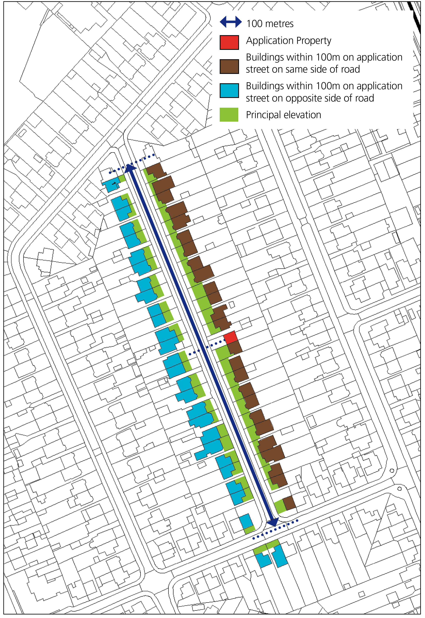

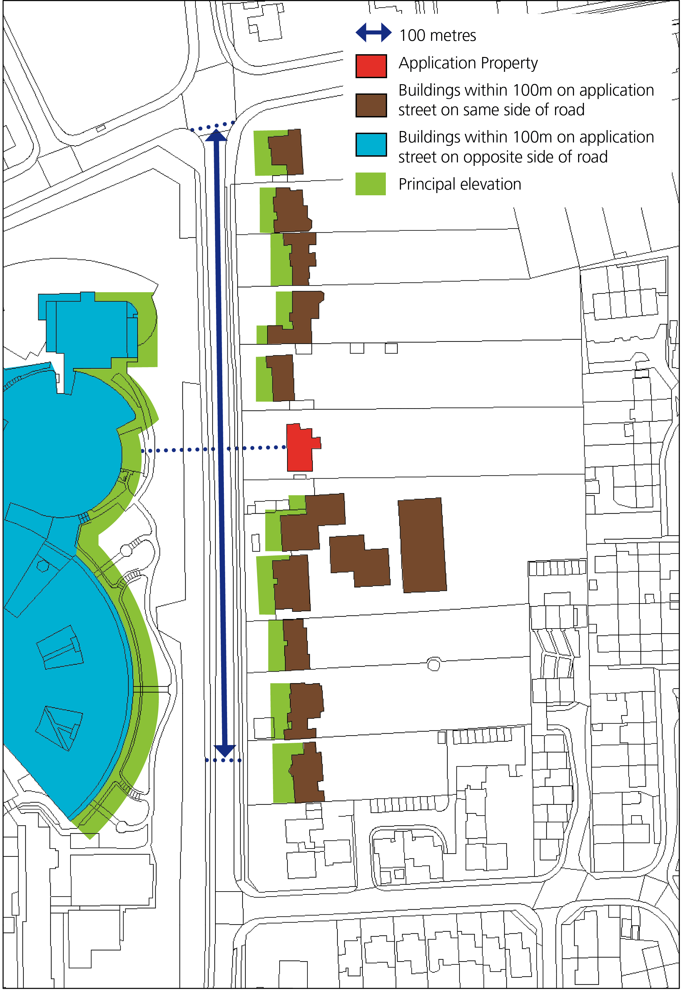

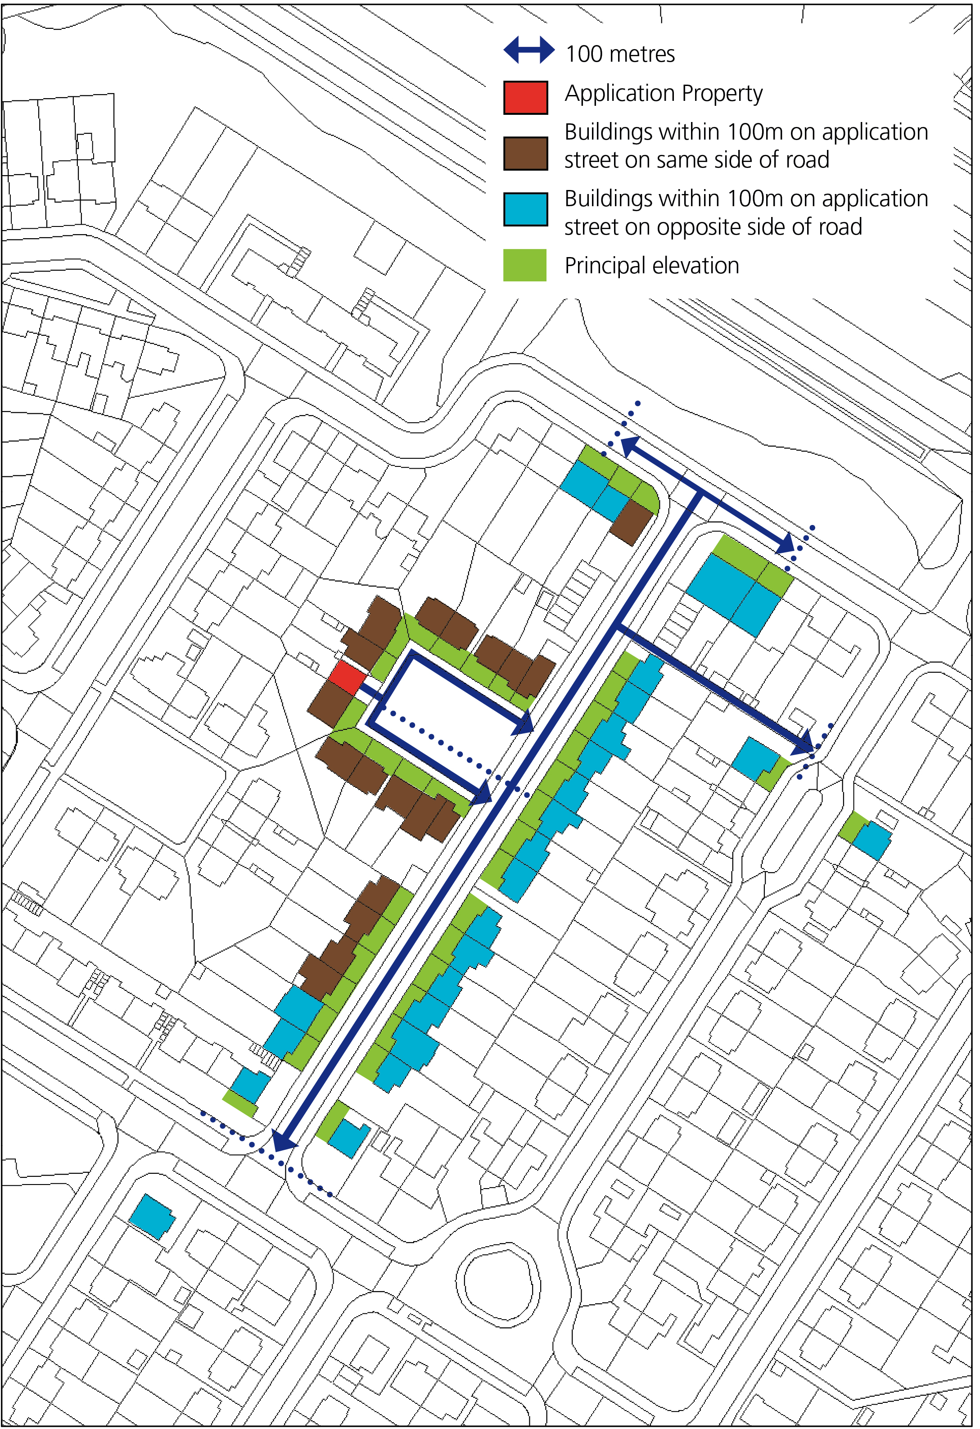

Appendix 2.3 Method for calculating thresholds for linking academic facilities with the adequate provision of student accommodation.
Student threshold calculation Policy H10 applies to full-time taught course students. To inform each annual Authority Monitoring Report the universities will be asked to provide information relating to their student numbers and the number of student accommodation rooms they provide and, in the case of Oxford Brookes, purpose-built student rooms they are aware are occupied by their students. A snapshot of information will be requested from a point in time in the Autumn of the monitoring year in question. The monitoring year is the one-year period from 1st April - 31st March. The ‘snapshot’ figures provided for the Annual Monitoring Report will be representative of the monitoring period and applicable to Policy H10. If a university is shown in the snapshot to be in breach of threshold, but are able to demonstrate a reduction in numbers during the year that brings them under their threshold, this will be accepted as an update by the City Council alongside an application for development of academic, research or administrative facilities. The universities will be asked to state how many students they have and specify how many of them are in each of the following categories. The following categories of students are not relevant for the purposes of Policy H10 and they will be excluded from the total number used in the calculation under Policy H10. There may be students who fall into more than one of these categories and they should not be excluded more than once:
- Part-time and short-course students
- Students studying a research based post-graduate degree
- Students studying a Further education course or a foundation degree
- Vocational course students who will at times during their course be training on work- placements including student teachers and health care professionals who have a split study arrangement between the university and the NHS including student nurses, midwifery students, paramedics, physiotherapists, occupational therapists and student doctors
- Students with a term-time address outside of the city (OX1, 2, 3, 4)
- Students living within the city (OX1, 2, 3, 4) prior to entry onto a course
- Students not attending the institution or studying at a franchise institution
- Students studying outside Oxford (e.g. at Oxford Brookes’ Swindon campus)
- Specific course exclusions (BTh Theology and MTh Applied Theology)
- Students who also have an employment contract with the university
- Students on a year abroad and other placement students away from the university
The following student accommodation types will be counted as university-provided accommodation:
- Purpose built student halls managed by the university
- Rooms in other student halls for which the university has nomination rights secured, or in the case of Oxford Brookes, also rooms in purpose-built student accommodation that they are aware their students are occupying during term times.
- Other university leased or owned housing stock
The number of students who meet the definition of the policy (i.e. the total number of students minus the exclusions detailed above) will be subtracted from the total number of student rooms provided by the university, and the resulting figure will be taken to represent the number of students living outside of university provided accommodation in Oxford.

Appendix 3 – Employment

Appendix 3.1 - Category 1 Employment Sites

The following university/research sites:
- University of Oxford Science Area and Keble Road Triangle, Old Road Campus, Radcliffe Observatory Quarter, Northern Gateway/Oxford North
The following hospital research sites:
- John Radcliffe Hospital, Nuffield Orthopaedic Hospital, Churchill Hospital, Warneford Hospital
The following major publishing sites:
- Mini Plant (BMW), Unipart
The following Science and Business Parks
- Oxford Science Park, Arc Oxford (Business Park)
The following key knowledge / innovation sector centres
- Oxford Centre for Innovation
- Wood Centre for Innovation
- Enterprise Centre and Bioinnovation Hub (Brookes University)
- BioEscalator (University of Oxford) (part of Old Road Campus- above)

Appendix 3.2 - Category 2 Employment Sites

City centre
Holywell (City Centre)
One St Aldate’s; Oxford Town Hall, St Aldate’s 1-16 King Edward Street; Blue Boar Court, Blue Boar Street; 109-113 St Aldate’s; 121 St. Aldate’s.
Osney & St Thomas (City centre)
Post Office, St. Aldate’s; Oxford University Officers Training Centre, Oxpens Rd; 6 Beckett St; 1-3 Cambridge Terrace; Speedwell House, Speedwell St; Albion House, Albion Place; Hogrefe House, Albion Place; County Hall, New Rd; 40 Pembroke St; Ramsay House, St. Ebbe’s St
Carfax & Jericho (City Cente)
13-16 Magdalen St; University Student Hub, Turl St; Clarendon House, Clarendon St; 10A New Road; 13 and 13A New Road; North Bailey House, 12 New Inn Hall Street; 29 New Inn Hall St; 17-33 Beaumont St; Chester House, 21-27 George St; 1-3 George St; 14-16 George St; The Old Fire Station, 40 George St; 3-7 Worcester Street.
West End and Botley Road
King Charles House, Park End St; Jam Factory, 27-30 Park End Street; Cantay House, 36-39 Park End St; 40-41 Park End St; New Barclay House, 234 Botley Rd; Osney Mead Industrial Estate.
Central Oxford & Jericho
Lucy Properties, Walton Well Rd; 35A Gt. Clarendon St; 30 St Glies; 35 St Giles.
Woodstock Road and Banbury Road
Belsyre Court, 57 Woodstock Road; 69-71 Banbury Road; 228-240 Banbury Road; Barclay House, 242 Banbury Rd; Mayfield House, 256 Banbury Rd; 264 Banbury Road; Suffolk House, 263-265 Banbury Road; Prama House, 267 Banbury Road ; Anchor House, 269 Banbury Road; Oxfam House, 274 Banbury Rd; 285 Banbury Rd; Cranbrook House, 287 Banbury Rd; Lambourne House, 311-321 Banbury Rd; Summertown Pavilion, 18-24 Middle Way; 20 Linton Rd; Jordon Hill Business Park, Banbury Rd.
London Road
75 London Road; 116-120 London Rd.
St. Clements and Cowley Road
Enterprise Centre, Standingford House, Cave Street; 1-4 The Plain; 27-28 St. Clements St; Angel Court, St. Clements; The Old Music Hall, 106-108 Cowley Rd; Former Blackwells Publishing, Marston St; Bullingdon House, 174B Cowley Rd; Crown House, 193 Cowley Rd; Newtec Place, Magdalen Rd.
Cowley and Horspath
21 Between Towns Rd; St. Luke's Church Temple Rd; 213 Barnes Rd; 244 Barnes Rd; Horspath Industrial Estate Pony Road, Horspath.
Garsington Road Cluster
Chiltern Business Centre, 198 Garsington Rd; Fenchurch Court, Bobby Fryer Close; Oxford Bus Company, Cowley House, Watlington Rd; Ashville Way, Watlington Rd; Oxford Trade Centre, Harrow Road; 1-3 Watlington House, Watlington Rd; Church Missionary Society, Watlington Rd; Lazarus House and Bishop Mews Transport Way; Chancery Gate Business Centre, Transport Way; County Trading Estate, Watlington Rd; Cowley Business Centre, Watlington Rd; Huw Grays, (formerly Buildbase), Watlington Road.
Sandy Lane West:
Nuffield Industrial Estate, Ledgers Close; Oxford Trade City.

Appendix 4 – A Green Biodiverse City that is Resilient to Climate Change

Appendix 4.1 - Urban Greening Factor

The Urban Greening Factor (UGF) is a planning tool used to improve the provision of Green Infrastructure and increase the level of greening on new development. Policy G4 sets out that all major development will need to demonstrate how it has included urban greening as a fundamental element of site and building design, demonstrating no net loss of greening score and that it meets the minimum target score for the development type (0.3 for predominantly residential and 0.2 for predominantly non-residential schemes). Its use is encouraged on other schemes as a way to assess current levels of greening and the changes proposed but is not mandatory.

The UGF score provides a figure for the proportion of urban greening in comparison to the total area of a given development site. It is based on the assessment of surface cover types within the site boundary, and is measured for the existing situation and post development conditions following building and landscape proposals. Each surface cover type is assigned a weighting factor (between 0.0 to 1.0) that reflects its environmental and social value in urban greening; its functionality in providing ecosystem services, including improving permeability; and its benefit in supporting biodiversity and habitat creation.

The UGF score is calculated by multiplying the area of each of the various surface cover types within the site boundary by its factor; each figure is then added together and divided by the total area within the red-line boundary of the development site. The result is assessed against the policy target score for the type of development.

Calculation of Urban Greening Factor Score

Urban Greening Factor Score | = | Sum of each Surface Area type (m2)  (Surface Area A x Factor A + Surface Area B x Factor B + Surface Area C x Factor C, etc.)
 |  | Total site area (m2)

For the purposes of Policy G4, the Local Plan follows the categorization of green infrastructure elements and surface cover types set out in the Green Infrastructure Standards from the Natural England Green Infrastructure Framework to calculate a UGF score. For surface cover types not specified on the list, a suitable approach will be to select the closest match in the description, in discussion with the Council where appropriate.

Natural England’s surface cover weightings* for the calculation of UGF Score.

No | UGF Surface Cover Type | Factor | General Description
 | Vegetation and Tree **Planting
1 | Semi-natural vegetation and wetlands retained on site (including existing / mature trees) | 1.0 | Protection and enhancement of existing vegetation within the development site including mature trees and habitats.
2 | Semi-natural vegetation established on site | 1.0 | New areas of vegetation and species-rich habitats within the development site that are connected to sub-soils at ground level.
3 | Standard / semi-mature trees (planted in connected tree pits) | 0.9 | Tree planting established within engineered and interconnected systems with structural soils to maintain tree health at maturity.
4 | Native hedgerow planting (using mixed native species) | 0.8 | Dense linear planting of mixed native hedgerow species, at least 800mm wide and planted two or more plants wide.
5 | Standard / semi-mature trees (planted in individual tree pits) | 0.7 | Tree planting established within separate designed tree pits with structural soils to maintain tree health at maturity.
6 | Food growing, orchards and allotments | 0.7 | Areas and facilities provided for local allotment and community- based food growing including formal orchards with fruit trees.
7 | Flower rich perennial and herbaceous planting | 0.7 | New areas of mixed native and ornamental herbaceous and perennial plant species to support seasonal cycles of pollinating insects.
8 | Mixed hedge planting (including linear planting of mature shrubs) | 0.6 | Dense linear planting of native or ornamental shrub and hedgerow species, closely spaced with one or more plants wide.
9 | Amenity shrub and ground cover planting | 0.5 | Areas of formal and informal non- native shrub and ground cover planting connected to sub-soils at ground level or in planters.
10 | Amenity grasslands including formal lawns | 0.4 | Areas of short-mown grass and lawn used for active sports or informal recreation that is regularly cut and generally species-poor.
 | Green Roofs and Walls
11 | Intensive green roof  (meets Green Roof Organisation / GRO Code) | 0.8 | High maintenance accessible green roof with planting and a depth of growing substrate with a minimum settled depth of 150mm.
12 | Extensive biodiverse green roof (meets the GRO Code, may include Biosolar) | 0.7 | Green roof with species-rich planting, with limited access, may include photovoltaics, the depth of growing substrate is 100 - 150mm.
13 | Extensive green roof (meets GRO Code) | 0.5 | Low maintenance green roof, limited species mix in planting and with no access, the depth of growing substrate is 80 - 150mm.
14 | Extensive sedum only green roof (does not meet the GRO Code) | 0.3 | Low maintenance sedum green roof, no access, combined depth of growing substrate, including sedum blanket, is less than 80mm.
15 | Green facades and modular living walls  (rooted in soil or with irrigation) | 0.5 | Vegetated walls with climbing plants rooted in soil supported by cables or modular planted systems with growing substrate and irrigation.
 | SuDS and water features
16 | Wetlands and semi-natural open water | 1.0 | Areas of semi-natural wetland habitat with open water for at least six months per year contributing to surface water management.
17 | Rain gardens and vegetated attenuation basins | 0.7 | Bio-retention drainage features including vegetated rain gardens and attenuation basins that also provide biodiversity benefit.
18 | Open swales and unplanted detention basins | 0.5 | Sustainable drainage systems to convey and temporarily hold surface water in detention basins with minimal vegetation cover.
19 | Water features (unplanted and chlorinated) | 0.2 | Ornamental and generally chemically treated water features providing amenity value but with minimal biodiversity and habitat benefit.
 | Paved Surfaces
20 | Open aggregate and granular paving | 0.2 | Porous paving using gravels, sands and small stones as well as recycled materials that allow water to infiltrate across the entire surface.
21 | Partially sealed and semi- permeable paving | 0.1 | Semi-permeable paving using precast units and filtration strips that allow water to drain through defined joints and voids in the surface.
22 | Sealed paving (including concrete and asphalt) | 0.0 | Impervious paving constructed of concrete, asphalt or sealed paving units that do not allow water to percolate through the surface.
*Correct as at time of publication. As the framework is new some information may be subject to change. Any updates will be published via the Green infrastructure and biodiversity TAN which applicants should refer to.
**Canopy measurements should be based on their extent on maturity or 25 year growth

A copy of the assessment matrix is available on the website to download. This should be completed and submitted along with the application. All surface cover types utilised in the assessment should be clearly highlighted on associated landscaping/elevation plans.

Appendix 4.2 - biodiversity points

In line with the requirements set out in policy G5, applicants are expected to incorporate a selection of features as part of the design of their development to support local species. Applicants should select features from the biodiversity points list in line with the below process and requirements, moving down pots in order as follows:

Type of application | Pot 1 requirements | Pot 2 requirements | Pot 3 requirements
Householder | All features (where applicable) | N/A | N/A
Minor development |  | 1 feature | 1 feature
Major development |  | 2 features | 2 features

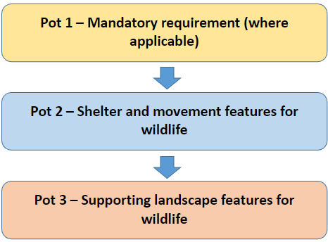
The policy requires that biodiversity features selected to secure the required points for an application are clearly demonstrated on related landscape/elevations plans submitted as part of the application. Requirements/design specs. The biodiversity points list is included below, however, the intention is for this to be kept as a ‘live list’ updated and/or added to throughout the lifetime of the Local Plan, therefore, the Green Infrastructure and Biodiversity Technical Advice Note should be referred to for the most up-to-date version where appropriate (along with additional guidance on the requirements of the list).
Pots |  |  | Biodiversity feature | Priority areas in Oxford | Additional details to be provided in Technical Advice Note
Pot 1 | Mandatory: Minor/Major | Mandatory: Householder | At least one swift box | If within an identified swift hotspot | Mapping and guidance on location/maintenance of boxes
 |  |  | At least one bat box | If within 200m of rivers/ woodland | Mapping and guidance on location/maintenance of boxes AND licensing requirements
 |  |  | At least one bird box per dwelling (resi) or per 1000m2 footprint (non-residential), including consideration of building-dependent species. | City-Wide
 |  |  | At least one bat box for every five dwellings (resi) or per 2000m2 footprint (non-residential) | City-Wide
 |  |  | Choose two of the following: insect hotel, planting for pollinators, night-flowering species | In valuable areas/  corridors identified in the TAN | Mapping and guidance on species choice
Pot 2 | Shelter and movement features for wildlife |  | Hedgehog highways in new boundary fencing | City-wide
 |  |  | Reptile hibernacula in suitable location | City-wide
 |  |  | Amphibian hibernacula in suitable location | City-wide
 |  |  | At least one insect hotels per dwelling (residential) or per 1000m2 footprint (non-residential) | City-wide
 |  |  | Provision of at least one dark corridor through the site | City-wide
Pot 3 | Supporting landscape features for wildlife |  | An appropriate amount of the trees and bushes on the site bear fruit/berries and/or nuts | City-wide
 |  |  | An appropriate amount of vegetation provides a range of food and host plants for local invertebrate populations | City-wide
 |  |  | Suitable size freshwater pond(s) designed to support aquatic species (no fish or invasive plant species) | City-wide

Appendix 5 – Carbon/resources

Appendix 5.1 - Additional external guidance on net zero carbon design

Guidance around designing buildings to net zero carbon standards is constantly evolving, however, there are a number of useful resources that can support applicants in designing buildings in ways that reduce their carbon footprint. Whilst the following are not Council resources and should be treated as independent, the below is a list of some external reference sources which may be helpful in implementing the requirements of policies R1, R2 and R3 of chapter 5:
- Low Energy Transformation Initiative (LETI): https://www.leti.uk/
- UK Green Building Council (UKGBC): https://ukgbc.org/
- Royal Insititute of British Architects (RIBA): https://www.architecture.com/about/policy/climate-action
- Climate Change Committee: https://www.theccc.org.uk/
- Passivhaus Trust: https://www.passivhaustrust.org.uk/
- Historic England (retrofit and energy efficiency guidance for historic buildings): https://historicengland.org.uk/advice/technical-advice/retrofit-and-energy-efficiency-in-historic-buildings/

A fuller list of guidance will be kept updated within the Energy and Carbon Technical Advice Note.

Appendix 6 – Design and Heritage

Appendix 6.1 - Conservation Areas

Oxford has 18 Conservation Areas at present. They include a diverse range of qualities from the compact college environment found in the city centre, the open green space found in the Headington Hill Conservation Area, to the vast meadows in Wolvercote and Godstow. See all conservation areas on a map. Architectural styles and landscape qualities are diverse, but they all have the common element of containing features that contribute to our historic past. It is the protection of these elements that need to be properly managed, ensuring future generations will value and enjoy their special qualities. Oxford’s Conservation Areas:
- Bartlemas
- Beauchamp Lane
- Binsey
- Central (University and City)
- Headington Hill
- Headington Quarry
- Iffley
- Jericho
- Littlemore
- North Oxford Victorian Suburb
- Old Headington
- Old Marston
- Osney Town
- Oxford Stadium, Sandy Lane
- St Clement’s and Iffley Road
- Temple Cowley
- Walton Manor
- Wolvercote with Godstow

Appendix 6.2 - Health Impact Assessment process

Health Impact Assessment
A Health Impact Assessment (HIA) is a tool used to identify the health impacts of a plan or project and to develop recommendations to maximise the positive impacts and minimise the negative impacts, while maintaining a focus on addressing health inequalities. By bringing such health considerations to the fore, HIAs add value to the planning process.
When is a Health Impact Assessment required?
Policy HD10 requires that a HIA is undertaken for major development proposals (e.g. 10 or more dwellings or 1000m² or more of non-residential development).
How to undertake a Health Impact Assessment?
The Council recommends that applicants refer to the Health Impact Assessment toolkit created by Oxfordshire County Council for resources and guidance on completing a HIA, which is available on their website. The scope of the assessment, extent of stakeholder engagement, as well as use of alternative HIA methodologies should be discussed and agreed with the relevant case officer to ensure a proportionate approach to the HIA is taken.
Whilst the specific details of what to include in the HIA will vary with the nature of the development, the HIA methodology should usually be structured into five key stages, which are outlined in greater detail in the Oxfordshire HIA toolkit:
1) Description of the proposed development;
This will need to include a description of the physical characteristics of the site of the proposed development site and surrounding area, including the current use.
2) Identification of population groups affected by the development;
Most proposals will not affect all individuals or groups across a community in the same way, so consider which groups of the existing population would be affected by the proposed development.
3) Identification of geographical area and associated health needs and priorities;
Identifying localised health priorities will enable a HIA to focus on the key issues for a particular location of a development, ensuring any HIA submitted to a Planning Authority is targeted and appropriately scoped so that it provides the most benefit. The expectation set out in policy HD10 is that analysis on health trends set out in the HIA is supported by appropriate evidence/data - for example from local health statistics.
4) Assessment of health and recommendations; and
A series of assessment tables should be completed for each of the health priorities identified as relevant to a proposed development guiding the reader through the process of establishing a baseline of the existing situation, building an evidence base around health impacts associated with a health priority, and identification of likely effects (positive and negative), and the population groups likely to experience these effects. The policy requires that mitigation measures are identified that can address any identified negative effects and these should be presented as part of this assessment.
Typical health priorities likely to be affected by a proposed development could include: Housing, Physical activity, Healthy food environments, Air quality, Noise, Traffic and Transportation, Crime and anti-social behaviour, Economy and Employment, Education and Skills, Local natural environment and access to green spaces, and Access to Services.
5) Monitoring.
The HIA should set out where the applicant will undertake monitoring in relation to the findings of the HIA. These should be linked to the proposed mitigation measures identified to address negative impacts from the development identified by the assessment and be S.M.A.R.T.
Please refer to both our Technical Advice Note and the online Oxfordshire Health Impact Assessment Toolkit for further information on how to complete a thorough HIA for major development in Oxford.

Appendix 6.3 - Privacy, daylight and sunlight: the 45 and 25 degree guideline
Many factors are significant in assessing whether new dwellings will enjoy adequate sunlight and daylight, both internally and externally, and the same factors must be taken into account when assessing the impact of new development on existing dwellings. Reflected light and the amount of sky visible affect daylight within a room or garden. Applicants must consider the function of the room or that part of the garden, and also whether other windows serve the affected room. Existing features including boundary walls, trees, proposed buildings and any change in ground level between sites are all relevant factors that also need to be taken into account. Applicants must also consider the impact on outlook - it is important not to create conditions that are overbearing (oppressive or claustrophobic) for existing or future occupiers. While development proposals will be considered in the light of these factors, as a guideline to assess their impact on daylight, sunlight and outlook, the City Council will use the guidelines illustrated below. In normal circumstances, no development should intrude over a line drawn at an angle of 45° in the horizontal plane from the midpoint of the nearest window of a habitable room and rising at an angle of 25° in the vertical plane from the sill. If a main window to a habitable room in the side elevation of a dwelling is affected, development will not normally be allowed to intrude over a line drawn at an angle of 45° in the vertical plane from the sill. Example 1 A single storey extension as shown below is generally acceptable if the projection is limited as shown in Plan (A). It may not be acceptable if the projection intrudes beyond the 45° line as shown in Plan (B)
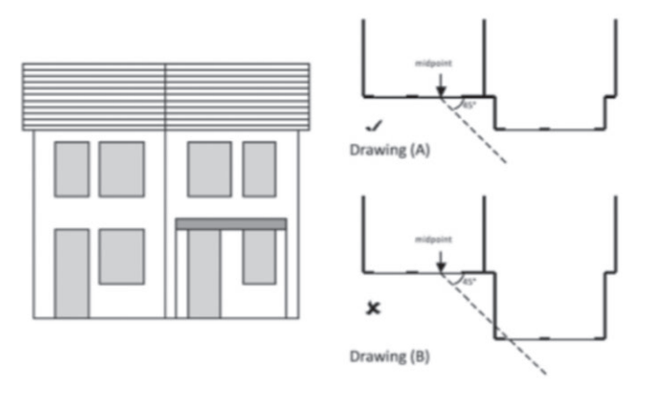
Example 2 If the 45° rule is broken, generally the proposal will still be acceptable if the line drawn outwards at 45° is tilted upwards at 25° from the sill level, and is unbroken by the highest part of the extension. This is shown as Drawing (C). The example shown as Drawing (D) is unlikely to be acceptable.
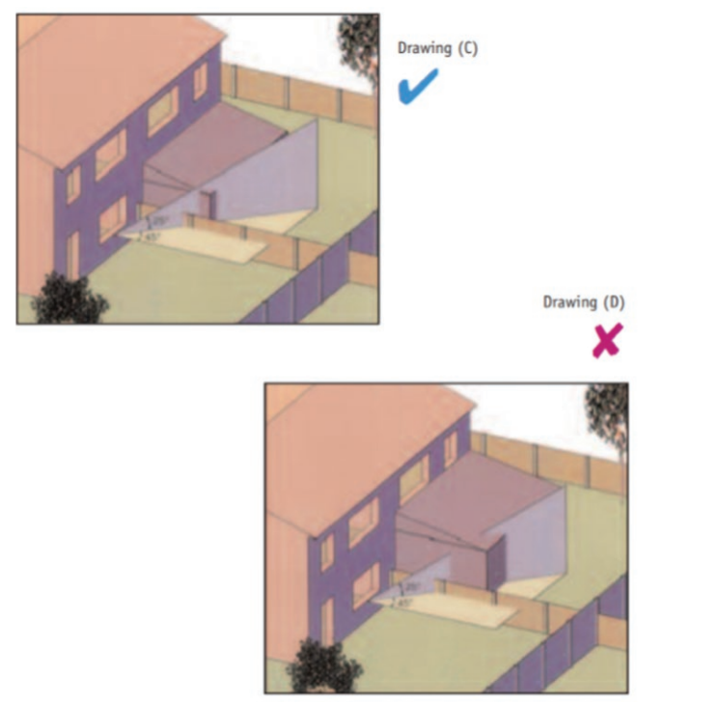

Example 3 If a main window to a habitable room in the side elevation of a dwelling is affected, development will not normally be allowed to intrude over a line drawn at an angle of 45° in the vertical plane from the sill.
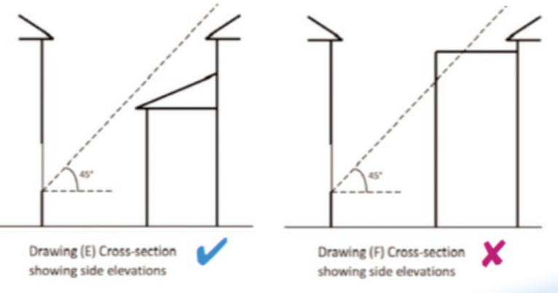

Appendix 7 – Communities

Appendix 7.1 - Marketing Expectations

- A property should be marketed for its existing use as a public house or live performance venue for a minimum period of at least 12 months, or for any other cultural or visitor attraction for its use or a use that meets similar needs.
- The applicant should then submit a supporting statement to accompany a planning application for a change of use that contains evidence to confirm the length of time the site has been marketed for; details of the agent used; information to show where this marketing has taken place for example in the local press, through signs on site, on the internet and/or in journals or publications used by the trade.
- The statement needs to confirm the price the property was advertised for to show that it has been pitched at a ‘reasonable’ rate to generate interest from potential operators.
- Finally there needs to be a summary of the interest received and the reasons why offers have not been accepted.

Appendix 7.2 - Transport Assessments

Where a Transport Assessment (TA) is required for a development proposal, it should be submitted alongside the planning application. The City Council may agree to the scope of TA being reduced if the development proposal is in a suitable location and in line with planning policy. TAs should address the desirable modal split and provide for a package of measures designed to reduce the role of car travel to the site. If the potential modal split is difficult to predict, the TA will need to consider whether and how far it may vary. The TA should be easy to understand for non-technical people.

Thresholds

The Transport Assessment will generally be required if the development:
- is likely to generate car traffic, particularly at peak times, in an already congested or heavily trafficked area;
- is likely to introduce a new access or additional traffic (any mode) onto a trunk road or other
dual carriageway;
- is likely to generate significant amounts of traffic in or near the city centre air quality management area (AQMA);
- is for a new or expanded school facility; and
- would be refused on local traffic grounds but where mitigation measures can be implemented to overcome any adverse impacts

Proposals over the following thresholds will require a detailed TA:
Food retail | 1,000m²
Non-food retail | 1,000m²
Leisure | 1,000m²
Cinemas and conference facilities | 1,000m²
Stadia | 1,500 seats
Offices | 2,500m²
B2 industry | 5,000m²
B8 distribution and warehousing | 10,000m²
Hospitals | 2,500m²
Higher and further education | 2,500m²
Residential | 40 dwellings
Freight movements | 10 per day

For mixed-use schemes, a detailed TA will be required where the combined effect of the uses proposed exceeds 10 freight or 200 vehicle movements a day, based on the general assumption that 100 vehicle movements are generated by 500m² commercial floorspace or 20 dwellings.

Proposals over 500m² or which may generate over 100 vehicle movements or 5 freight movements per day will require at least a transport statement. For residential development in Oxford, this equates to developments of 20 dwellings or more.

Contents

All TAs and TSs must include a non-technical summary and must address:
- location and layout including access and egress points;
- size, in terms of site area and floorspace per activity; and/or number of dwellings and number of bedrooms per dwelling; and use of the site eg. staff, students, patients, visitors;
- proposed uses and activities; and
- issues such as timing and type of access requirements

Where a detailed TAs is required, this must additionally address the following:
- Potential travel characteristics: accessibility by all modes and predicted modal split. TA should consider ease of access and catchment areas by travel-to-site times for each mode.
- Measures: influencing travel patterns and minimising the need for parking using measures to improve access by walking, cycling or public transport in order to minimise non-essential car travel. TA should consider appropriateness of location, scale, density and uses of the site and development.
- Impact appraisal and mitigation: maximising accessibility by sustainable transport modes such as through minimising prominence of car parking, management of access and parking, and organisational policies. TA should determine whether the development is acceptable or not in terms of the transport impacts, and propose measures to mitigate the impacts in terms of accessibility, integrating modes of travel, reducing environmental impact and promoting safety.

Appendix 7.3 - Travel Plans

If a Travel Plan (TP) is required for a development proposal, it should be submitted with the planning application.

Thresholds

TPs must be submitted alongside planning applications if the development:
- is likely to generate significant amounts of travel in or near the city centre air quality management area (AQMA);
- is for new or expanded school facilities; and
- would be refused on local traffic grounds but where the TP sets out to overcome any adverse impacts.

Proposals over the following thresholds will require a TP:

Food retail | 1,000m²
Non-food retail | 1,000m²
Leisure | 1,000m²
Cinemas and conference facilities | 1,000m²
Stadiums | 1,500 seats
Offices | 2,500m²
B2 industry | 5,000m²
B8 distribution and warehousing | 10,000m²
Hospitals | 2,500m²
Higher and further education | 2,500m²

TPs must recognise the potential for modal shift and therefore the early stages of the TP are likely to focus on those car drivers "most able" or "most likely" to change their mode of travel. This does not mean that other categories should be neglected. Greater effort in terms of more measures will be needed in the longer term to address the needs of those less likely to switch from driving.

The reasons for car use, the distances travelled, and from where journeys start, and finish must be assessed. There are many ways that information could be assessed and represented in the TP.
For example, on a proposal to expand an existing site, surveys of current staff would be useful. For a relocated organisation, current staff surveys could indicate travel habits at the new site. An isochrone map can be useful in indicating distances from a site, accessibility by various modes, or potential catchment areas.

Modal split targets are normally displayed as percentages. However, this does not address the issue of rising staff numbers for example, and over time may in fact hide an increase in the number of cars being brought to a site. Targets should be stated as actual numbers as well as percentages.

Contents

There is no right or wrong way to present a useful and effective TP. However, the following guidelines should be considered:

Background:

Information about the organisation must be stated clearly, including:
- Staff details such as numbers (for example, full-time/part-time, staff on payroll/fulltime equivalents^{[1]}), times of travel (for example, Monday to Friday at 9am and 5pm or shift pattern), where they travel from, and how they currently travel;
- Site assessment including current access and egress (pedestrian/cycle/vehicular) into and within the site, cycle facilities, accessibility by public transport, accessibility of nearby shops and services, and car parking;
- Assessment of non-staff travel (for example, visitors, deliveries, fleet vehicles);
- Attitudes of staff towards travel to and from the site and towards their travel needs.

Objectives:

The statement of objectives should identify the motivation behind the TP and clearly state its purposes. (For example, reasons for a TP include reductions in car usage (especially single occupancy journeys at peak times), and increased use of walking, cycling and public transport). It may be relevant to address:
  - Reducing traffic speeds, improved road safety and personal security (especially for people on foot or cycle); and
  - More environmentally friendly delivery and freight movements, including home delivery services.

Measures:

The TP must identify what needs to be done to achieve its objectives and what measures need to be implemented.

Targets:

Targets must be specific, measurable, realistic and split into identifiable time frames based on the short term, medium term and long term and preferably dated by month and year.

Monitoring and Review:

The effects of TPs must be monitored, and they must state clearly how monitoring will take place (for example by stating what will be monitored by whom and when). Baseline data must therefore be provided (for example, as part of the background information). The outcome of monitoring may suggest that a review of the measures and/or targets is necessary. (For example, it is not necessarily a bad thing to discover through monitoring that a measure is no longer feasible, but new measures will then need to be set to meet the objectives of the TP.)

Enforcement:

The TP must set out arrangements for appropriate enforcement action in case agreed targets are not met.

^{[1]} Some staff may be part-time or job-share, so the number of posts in an organisation and the number of staff it employs may differ. Full-time equivalents (FTEs) are the number of equivalent full-time posts in an organisation.

Appendix 7.4 - Bicycle Parking Standards

Houses and flats up to 4+ bedrooms | 2 spaces per bedroom
HMOs | 1 space per bedroom
Student Accommodation | At least 3 spaces for every 4 study bedrooms
Hotel/Guest Houses | At least 1 spaces per 5 non-resident staff (or other people). Plus 1 space per resident staff.
Shops other than non-food retail warehouses, financial and professional services | 1 space per 113m²
Businesses | 1 space per 90m² or 1 space per 5 staff or visitors.
Food and drink | 1 space per 40m² public floor space.
Non-food retail warehouses including garden centres | 1 space per 400m².
General industry warehousing/distribution traders’ merchants | As B1 up to 235m². 1 space per 5 staff or visitors.
Places of assembly including cinemas, theatres, stadiums and concert halls. | 4 spaces per 10 seats up to 1,000 seats; 1 space per 100 seats thereafter.
Places of worship/community centres/public halls | 2 spaces per 20m² of seating/assembly floor space
Libraries | 1 space per 200m².
Medical clinics/dentists | 1 space per treatment room plus 1 space per 5 staff or visitors
Hospitals | 1 space per 5 staff or visitors
Public sports facilities | 1 space per 5 staff plus additional provision to be determined on its merits with the  following guideline; 1 space per 105m².
Primary schools | 1 space per 10 pupils.  Plus 1 space per 3 staff or visitors.
Secondary/schools | 1 space per 2 pupils.  Plus 1 space per 3 staff or visitors
Non-residential higher/further education | 1 space per 2 students (based on anticipated peak number of students on-site at any one time).  Plus 1 space per 5 staff.
Other developments | To be treated on their individual merits, guided by the general principle of 1 space per 5 people.

Bicycle parking provision should be made on the site. If there is a shortfall of on-site parking provision, a contribution may be sought towards off-site bicycle parking or associated facilities, based on the standards set out in this appendix.

The standards will be applied to ensure that there would be adequate provision if permitted development were carried out, unless applicants are willing to accept a condition restricting their permitted developments rights in this respect.

The reference to staff should be taken to mean the peak number of staff expected to be onsite at any one time, whether part-time or full-time.

The standards are intended as minimum standards for new development and where appropriate, change of use. One space means that one bicycle can be secured. A bike stand for example a Sheffield style stand, can provide two bicycle-parking spaces.

Bicycle parking should be future proofed to ensure that the infrastructure to support the
charging of electric bicycles is supported.

Appendix 7.5 - Shower, changing room and locker facilities provision in commercial/non residential development

The City Council will seek the provision of shower, changing and locker facilities in commercial/non residential developments on the following basis:

Office | 1 shower per 500m² up to 1000m², 1 shower per 4,000m² thereafter.
Warehousing and retail warehousing | 1 shower per 5,000m² up to 10,000m², 1 shower per 8,000m² thereafter
Other | 1 shower per 2,500m² up to 10,000m², 1 shower per 4,000m² thereafter

The application of these standards will be subject to the merits of each proposal. Except where specified, all areas quoted refer to gross floor measured externally, I.e., where proposals are submitted to extend, consolidate or reconfigure an existing site, these standards may be applied to the site as a whole rather than just the additional floor space, to ensure adequate provision on site.

Appendix 7.6 - Vehicular Parking Standards

Residential Parking Decision Flow Diagram:

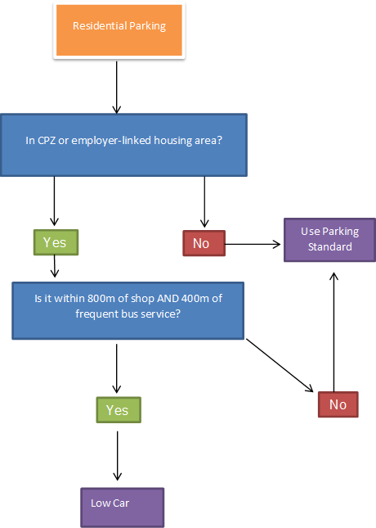

Vehicular parking standards:

Policy C8 sets out Oxford City Council’s policy on providing parking for new residential developments. The standards below should be read alongside Policy C8 and the supporting text.

Any dwellings* | 1 space per dwelling (may be allocated or unallocated) to be provided within the development site
Houses in Multiple Occupation | Parking standards to be decided on a case-by-case basis
Wheelchair accessible or adaptable houses and flats | 1 space per dwelling, to be provided on-plot (must be designed for wheelchair users in accordance with Part M of Building Regulations)
Retirement homes | 1 space per 2 residents’ rooms
Sheltered/extra care homes | 1 space per 2 homes plus 1 space per 2 staff
Nursing homes | 1 space per 3 residents’ rooms plus 1 space per 2 staff
Student accommodation | 0 spaces per resident room. Operational parking and disabled parking to be considered on a case-by-case basis in accordance with Policy H9.

*Any parking provided on plot to be excluded from a permit for any future CPZ and only 1 permit to be provided per dwelling on street when not provided on plot.

Disabled Parking/Blue Badge Holders:
On developments of 4 or more homes, wheelchair accessible or adaptable homes should provide allocated for blue badge holders/disabled parking, irrespective of location. On sites of 20 or more homes blue badge holders/disabled parking should be provided for at least 5% of dwellings. Disabled parking should have level access to, and be within 50 metres of, the building entrance which it is intended to serve.

Low car parking standards for working drivers, pooled cars/car clubs and visitor spaces:
0.2 car parking spaces per 20 units should be provided on site for working drivers, service and delivery vehicles, pooled cars/car clubs and visitor spaces. For sites which are constrained evidence must be submitted to satisfy the local planning authority as to why this threshold should be reduced.

Powered Two Wheelers:

Residential | 1 space per 5 dwellings
Non-residential developments | 1 space per 400m² up to 2000m^{2,} 1 space per 1000m² thereafter.

Non-residential development:

Existing employment uses | No additional increase in parking spaces
All other uses | To be determined through pre-application meetings/planning applications in the light of their Transport Assessment and Travel Plan.

https://futureoxfordshirepartnership.org/projects/oxfordshire-health-impact-assessment-toolkit/
* For the purpose of these guidelines, patio doors and glazed French doors will also be treated as windows. Cill level will be judged in accordance with other principle windows in the same part of the dwelling, or in neighbouring dwellings
** For the purpose of these guidelines, habitable rooms include kitchens as well as living rooms, dining rooms, studies, bedrooms and/or playrooms

